**Task1** : Registration Form

Step 1: first we are creating folder use this command

mkdir register_form

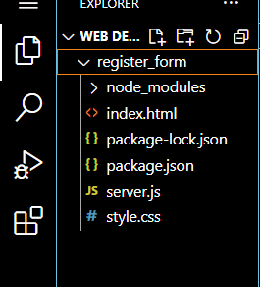

Step 2: Then we are going inside the folder.

cd register_form

Step 3: After that we are using init command

npm init -y

Step 4: For this I am doing install dependencies

npm install express mongoose body-parser

Step 5 : then we are create html file and doing code

Step 6 : we are create css file name is style.css and doing style of this code

Step 7: we are create a file name is server.js file

Step 8: open monego and run mongo db server to connect this

Mongod

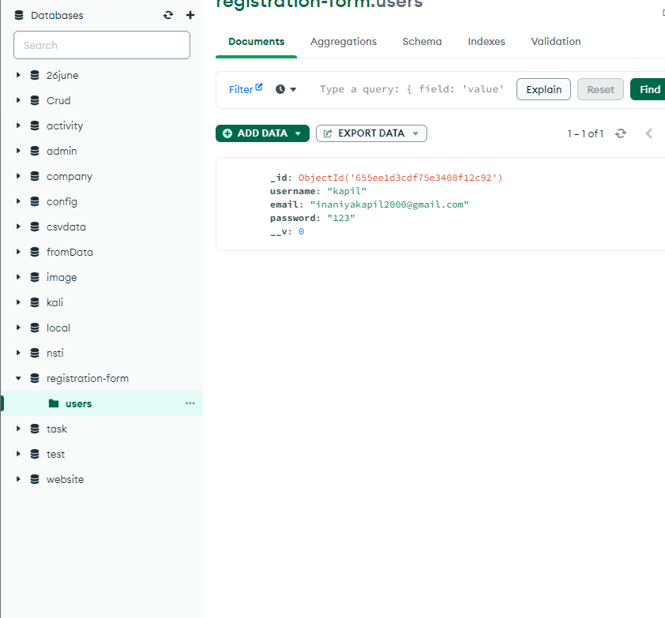

Step 9 : after then we are run the application

node server.js

